**Table of Contents**

1. Executive Summary 3

1.1 Project Overview 3

1.2 Purpose and Scope of this Specification 3

2. Product/Service Description 3

2.1 Product Context 3

2.2 User Characteristics 3

2.3 Assumptions 3

2.4 Constraints 4

7.1 Dependencies 4

11. Requirements 4

11.1 Functional Requirements 4

11.2 Security 5

11.2.1 Protection 5

11.2.2 Authorization and Authentication 5

11.3 Portability 5

12. Requirements Confirmation/Stakeholder sign-off 5

13. System Design 5

13.1 Algorithm 5

13.2 System Flow 5

13.3 Software 6

13.4 Hardware 6

13.5 Test Plan 6

13.6 Task List/Gantt Chart 7

13.7 Staffing Plan 7

# Executive Summary

## Project Overview

This project is about using robotics to complete a series of tasks. The intended audience is the classroom in which the project was given and specifically, our classmates and professor. We also could use these robots to introduce new people into coding when everything is fully functional; once people see how cool and fulfilling it is to program robots to move in a controlled environment, we can draw more attention to software/computer programming.

## Purpose and Scope of this Specification

The intended purpose of this project is to follow a series of steps and processes given to us by our instructor. This includes:

* Following a figure 8 path with proper accuracy at an appropriate speed
* Moving around the course while “speaking” to the user and changing LED colors at the end
* Keeping a consistent speed while traversing around the course and following all steps in the Sphero program
* Showcase looping feature to drive the robot around the course five times

# Product/Service Description

The general factors that affect our product is the programming of the robot itself and how computers utilize this hardware. We also use the website Sphero.edu and a Bluetooth connection to run block code (to make the robot function the way we want). Our robot is among the latest models (Bolt), but overall, with proper computer/phone software, a Sphero robot, and a stable Bluetooth connection, this project should be possible to complete.

## Product Context

Our robots can be compared to other robot services/products, due to the simplistic nature of how easy it is to connect. There are many other robotic sites that come with purchasable robots/machines to control, however, the robots we are using, and the user interface run by Sphero.edu is a completely independent service. The website is run over Bluetooth connection and is very easy to use when a Sphero robot is present; the site they use as well Is their own in terms of the block code and doesn’t rely on other sites such as code.org.

## User Characteristics

* Student/Classmate – Age (18 – 23) – College Education Level – Software/Computer Science Expertise – First to second year work in robotics and programming
* Teacher – Age (30 – 80) – Masters/Bachelors/PhD level Education – Software/Computer Science expert – Multiple years working in the field of robotics/software development
* Regular consumer – Age (5 – 70) – Any education level – Any major/profession – New or existing knowledge of programming/software

## Assumptions

Any of the following assumptions will affect the requirements. A brief description to explain each assumption may help as well.

* Use of a windows computer (This will not affect the robots’ capabilities, but the sensory data portion of Sphero.edu will be affected. It is easier to use this website/app on Mac)
* User Expertise (This will not be a complete deal breaker, since any knowledge range can be used with the robot, but some functions/code will appear difficult and making the robot complete a certain task will be harder with less knowledge)
* Chromebooks and iPad devices are compatible with the Sphero robots (Recommended to use Windows computers or MacBook devices with the capabilities of IOS 14 and up)

## Constraints

* Parallel operation with an old system (IOS 14 and below + Windows 12 and below)
* Room availability (the product will not complete all tasks without proper preparation times. If we are unable to meet at least 3 times, the results will not show as intended)
* Lack of access to the Sphero Website, unprofessional management, and faulty security (all these factors will prohibit the best possible work achieved and if present can be detrimental)
* Criticality of the application (if the Sphero robot itself was to shut down or malfunction, the work process may be affected)
* System resources (bad battery usage of our main computer, the failure to bring work devices, and limited storage to store our documents)

## Dependencies

* The workspace reception being effective enough to run the program code
* The Wi-Fi adapter/Intel graphics cards of our computers (Having accessibility to Apple’s EN0, and Mac OS software)
* Robot designed by Sphero or another robot with the capabilities to run through the main website

# Requirements

**Priority Definitions**

* Priority 1 – Must have an established Bluetooth/Wi-Fi connection with Sphero robot and website
* Priority 2 – Sufficient computer with adequate processor, CPU, and graphics cards (should be a Mac OS system for best production/accessibility to sensory data and graphs); Mac is not needed, Windows is sufficient but does not give entire access to website
* Priority 3 – More advanced type of robot, course picture/walkthrough, Google documents that list every step along the testing process (which can be done with the “notes” portion of the Sphero website). In our case we used Microsoft Word and draw.io to document all our progress.
* Priority 4 - Calibrate the machine in order to follow directions of the course
* Priority 5 - Test robot enough times to perfect the course, change color, and talk to user
* Priority 6 - Record video of Sphero robot traversing the course accurately

**Extra rules/priorities followed:**

* Robot begins at starting point (axis of two circles)
* Robot travels on path provided (figure 8 shape)
* Robot stays within the square path of the course
* Robot spins 360 degrees to complete first circle
* Robot spins 360 degrees to complete second circle
* Robot avoids contact with obstacles in the process
* Robot finishes at starting point (axis of two circles)
* Robot speaks the dialogue as follows: “I am the winner”
* Robot flashes 10 colors before program ends

## Functional Requirements

| **Req#** | **Requirement** | **Comments** | **Priority** | **Date Reviewed** | **SME Reviewed / Approved** |
| --- | --- | --- | --- | --- | --- |
| ACC_01 | Start in axis of both circles | This was not an issue besides the matter of aiming the robot in the right direction. | 1 | 11/15/23 | Approved |
| ACC_02 | Travel on path | We managed to get the robot to more or less follow the path exactly after a few tries. | 2 | 11/15/23 | Approved |
| ACC_03 | Stay within square path (figure 8 course) | We weren’t able to perfect it due to discrepancies of the course and classroom (duct tape marking the course, unevenness of the floor, etc.). Overall, we ended up with acceptable results at the end. | 3 | 11/15/23 | Approved |
| ACC_04 | Spin 360 degrees for first circle | This was simple with the use of geometry. | 4 | 11/15/23 | Approved |
| ACC_05 | Spin 360 degrees for second circle | This was in relation to getting the robot to land on the axis it started. Once we figured how to get it back to the starting point, the second circle followed the first. | 5 | 11/15/23 | Approved |
| ACC_06 | Loop both circle spins 5 times | The first two spins were a success; we only needed to add the loop function to the code. | 6 | 11/15/23 | Approved |
| ACC_07 | Avoid collisions (tables, chairs, etc.) | We cleared everything out of the way of the course, except for the tape placement marking the course (which affected our data slightly). | 7 | 11/15/23 | Approved |
| ACC_08 | Finish in axis of both circles (starting point) | This was in relation to the second circle and the loop. Programming to stop the robot at the axis after multiple attempts helped to end the trial correctly. | 8 | 11/15/23 | Approved |
| ACC_09 | Speak “I am the winner” | We added a speaking function to the code using the dialogue. | 9 | 11/15/23 | Approved |
| ACC_10 | Flash multiple colors (10) | We used a new mechanic called “strobe” to flash multiple LED colors at the end. | 10 | 11/15/23 | Approved |

## Security

### Protection

* Ensuring only group members can access and edit repository contents.
* Sphero must be within range of the host computer to operate remotely.
* Programs used for the system must be trusted and free of malware and whatnot.

### Authorization and Authentication

* Each group member must accept the invitation to the proper repositories to be given permission to edit repository contents.
* Login confirms the identity of the person (using the correct username and the correct password) and grants access to the site under their respective username.

## Portability

* The Sphero application provides its own block coding program for robot operation.
* Each of the three group members mainly uses a different operating system.
  + Windows, MacOS, and ChromeOS are all compatible with Sphero to different extents.
* Computers must connect with the robot and follow the block code effectively regardless of the operating system used.
* The course is a rectangular track marked by blue duct tape on the floor of a classroom of an appropriate size.

# Requirements Confirmation/Stakeholder sign-off

|  |  |  |
| --- | --- | --- |
| **Meeting Date** | **Attendees (name and role)** | **Comments** |
| 11/14/23 | Jalen (manager), Jimmy (video recorder) | This meeting led to a success of the block code creation and video recording. |
| 11/15/23 | Jalen (manager), Jimmy (video recorder), Jared (algorithm and flowchart creator) | This meeting allowed us to complete the project and prepare the system design document. |

# 

# System Design

## Algorithm

**First block code:**

* On Start Program
* Loop 5 times
* Speed 35
* Spin 360 degrees for 20 seconds
* Speed 35
* Spin -360 degrees for 21 seconds
* Stop
* Speak "I am the winner" and wait
* Strobe red for 0.5 seconds one time
* Strobe light green for 0.25 seconds one time
* Strobe light blue for 0.5 seconds one time
* Strobe beige for 0.5 seconds one time
* Strobe purple for 0.25 seconds one time
* Strobe pink for 0.2 seconds one time
* End program

**Second block code:**

* On Start Program
* Loop 5 times
* Speed 90
* Spin 360 degrees for 8.3 seconds
* Stop
* Speed 90
* Spin -360 degrees for 8.2 seconds
* November 16, 2023
* Sprint 1 - Endurance Design Document
* Stop
* Speak "I am the winner" and wait
* Strobe yellow for 0.5 seconds one time
* Strobe green for 0.5 seconds one time
* Strobe red for 0.5 seconds one time
* Strobe cyan for 0.5 seconds one time
* Strobe purple for 0.5 seconds one time
* Strobe light pink for 0.5 seconds one time
* 10. Strobe blue for 0.5 seconds one time
* 11. Strobe peach for 0.5 seconds one time
* 12. Strobe light green for 0.5 seconds one time
* 13. Strobe light blue for 0.5 seconds one time
* End program

**(There is a page break due to formatting, but overall flow of reading is not affected)**

## System Flow

<https://drive.google.com/file/d/1_VOpX6VfqhmYIXD3StEJHB3FmJa18cXR/view?usp=sharing>

* **Zoom 200% for better visibility**
* **Read block code left to right**
* **Each square corresponds with each other in the flowchart diagram**

**(Apology in advance because block code exceeded the initial page)**

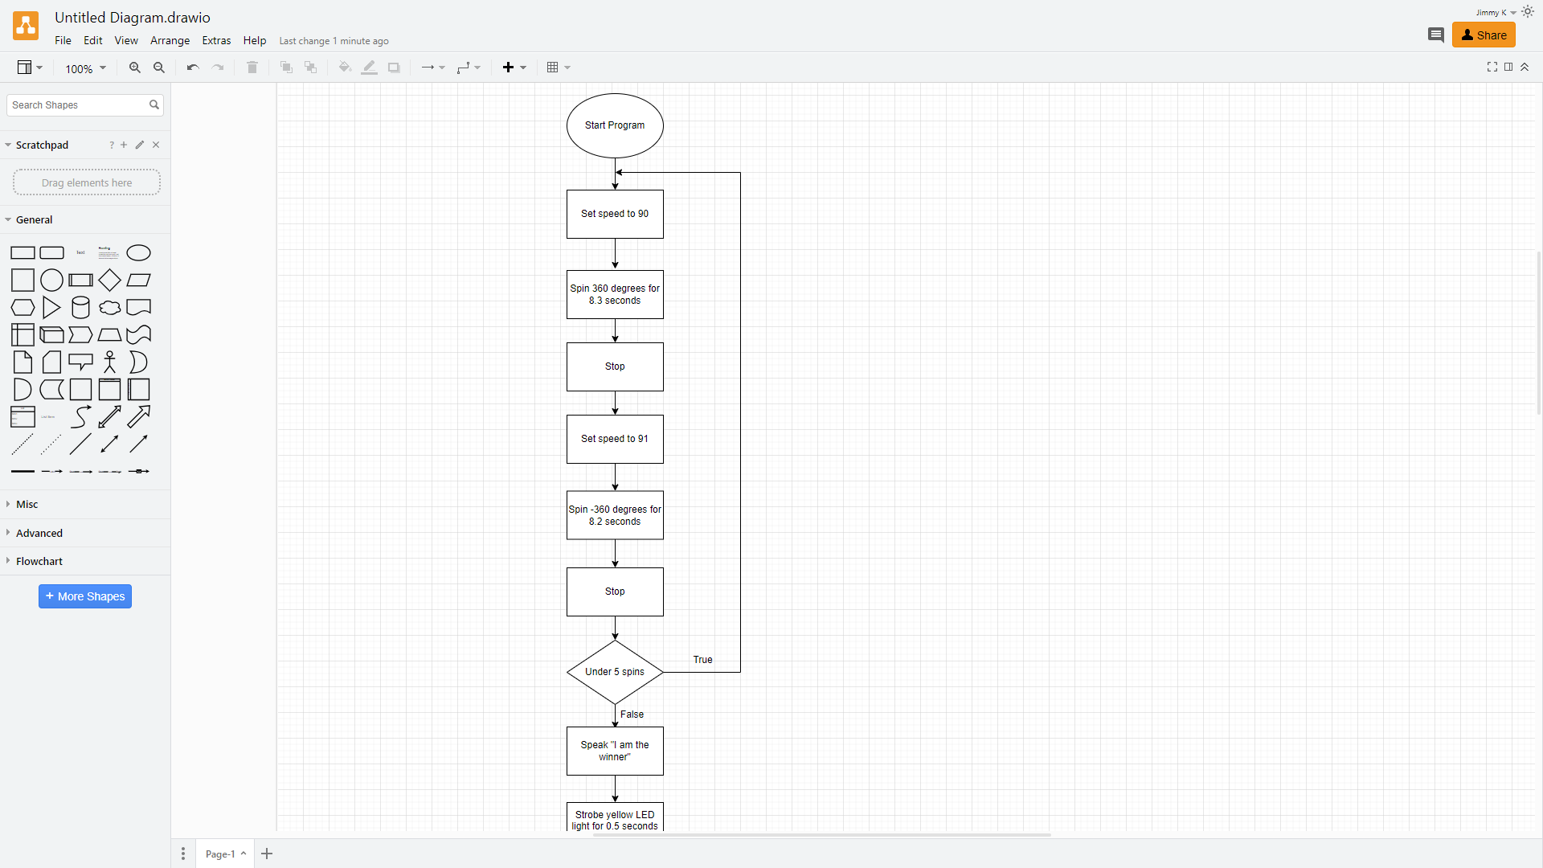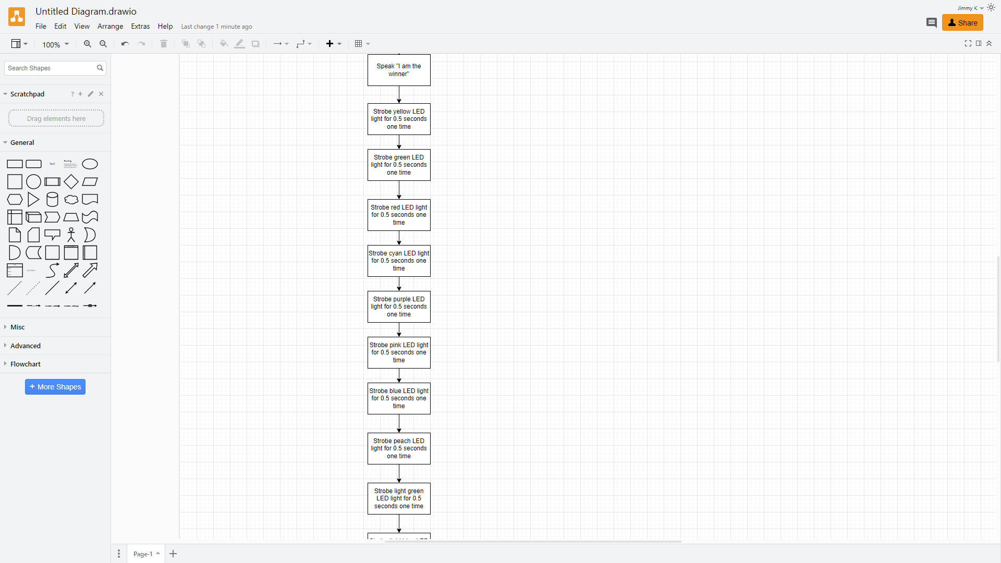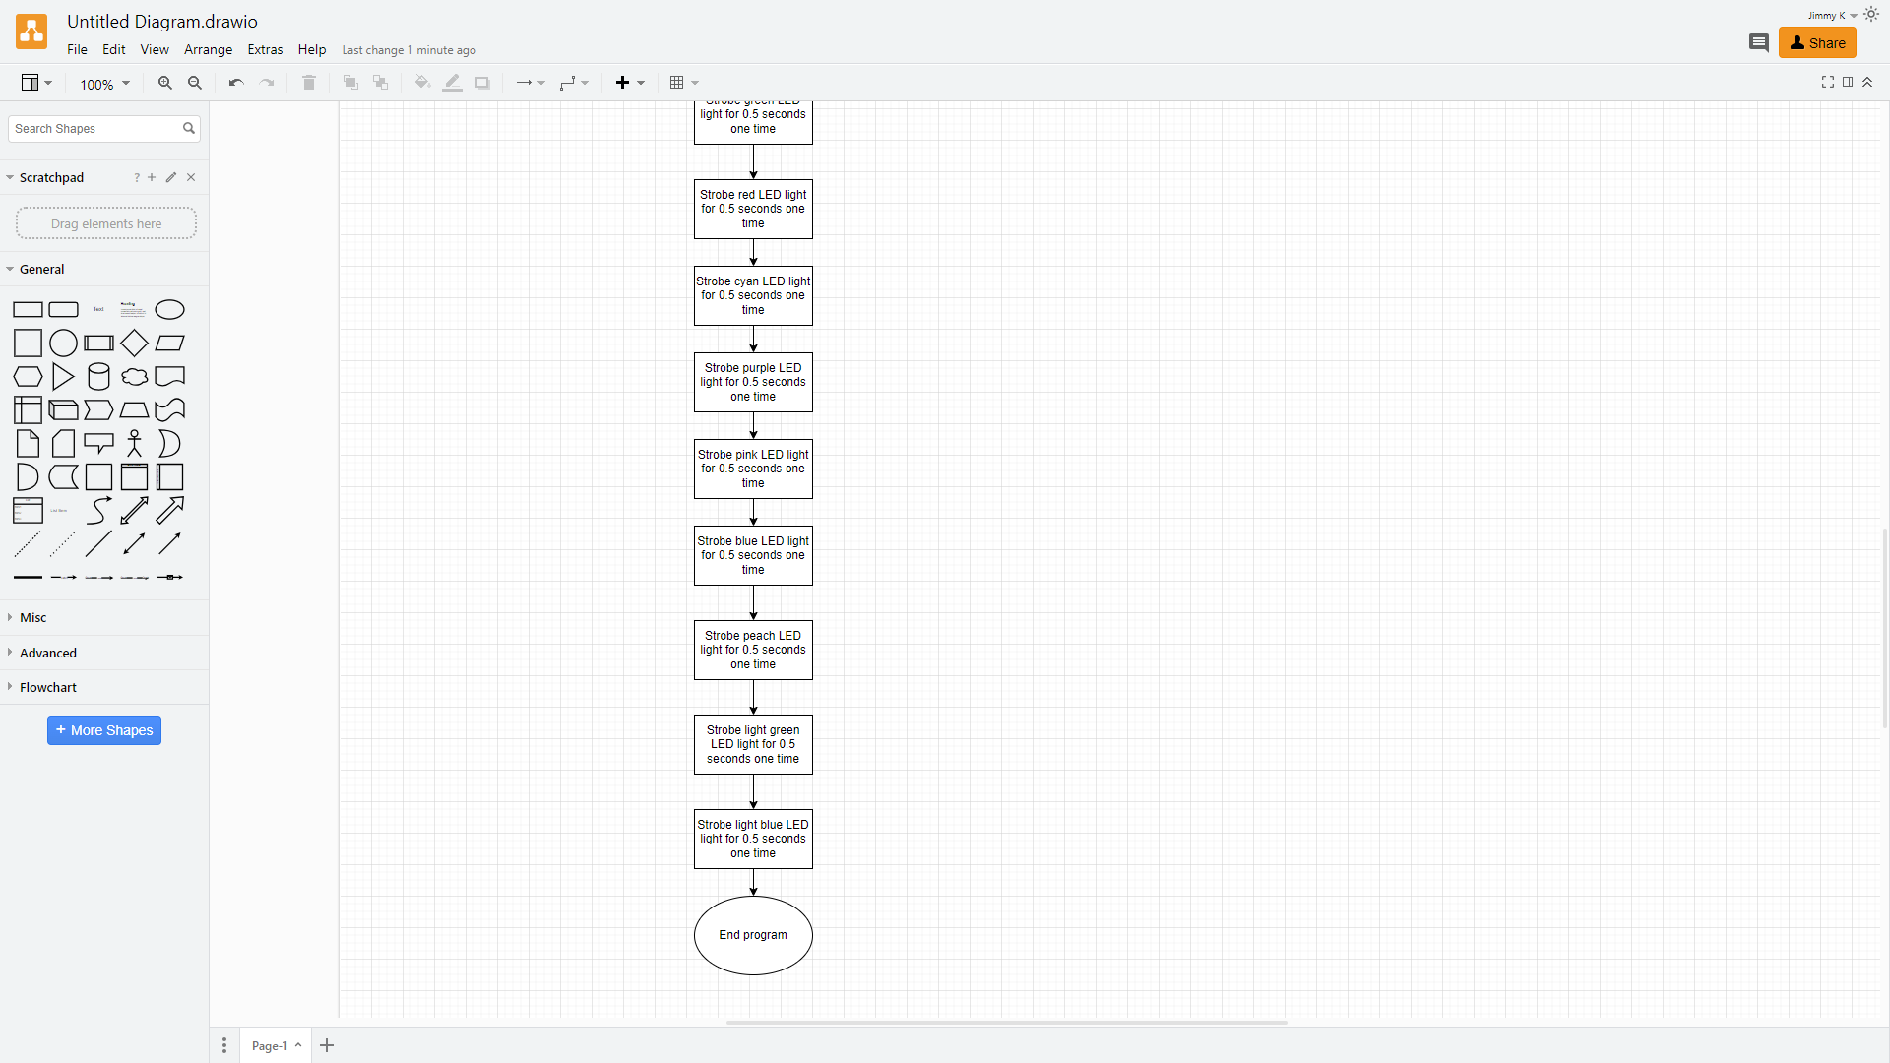

**This is the flowchart for one of our programs because it yielded the best results on video (the second block code below)**

## Software

Sphero 6.6.0 | Operates on Java | Written to give sphere-shaped robots the ability of motion by drawing paths through the app via block code.

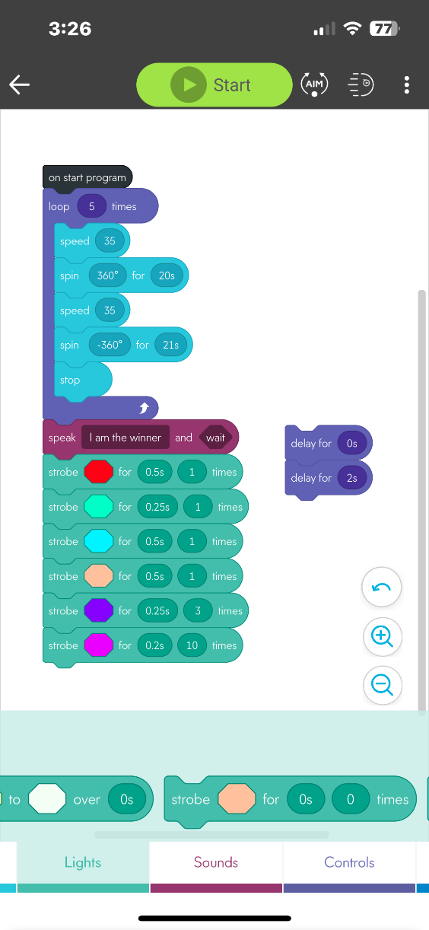

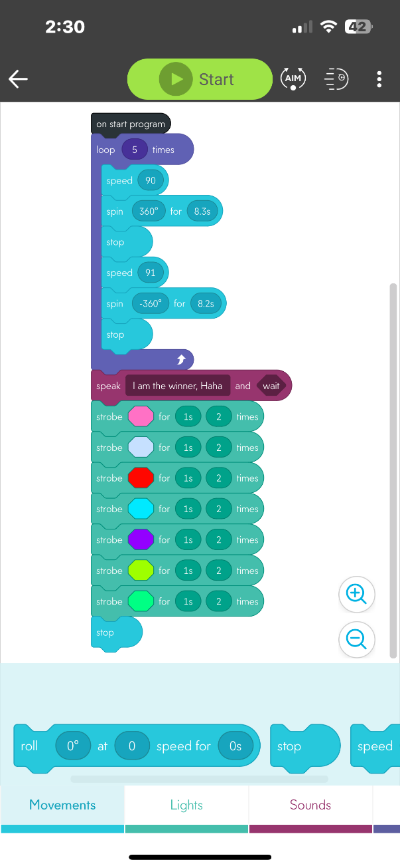

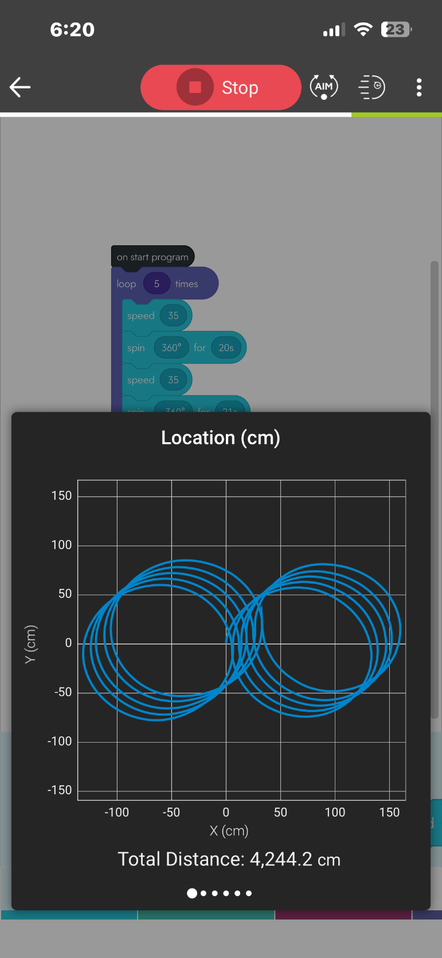

**(The sensor data diagram on top represents the first block code above and the bottom diagram represents the second block code above)**

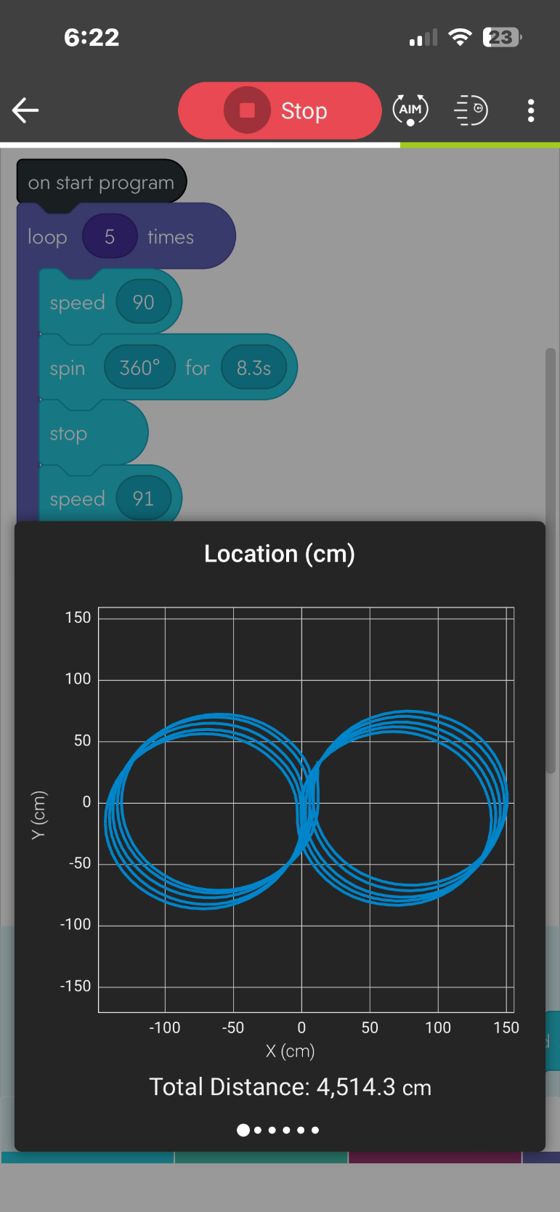

## Hardware

MacBook Pro 15-Inch, 2019 | Processor 2.3 GHz 8-Core Intel Core i9 | Graphics Intel UHD Graphics 630 1536 MB | Memory 16 GB 2400 MHz DDR4 | MacOS Ventura 13.5.2

## Test Plan

| **Reason for Test Case** | **Test Date** | **Expected Output** | **Observed Output** | **Staff Name** | **Pass/Fail** |
| --- | --- | --- | --- | --- | --- |
| Start in axis of both circles | 11/14/23 | Expected to fail based on aiming mechanic (on the first attempt) | It followed our initial observation and adjusted because of the initial trial | Jimmy, Jalen | Fail |
| Start in axis of both circles | 11/14/23 | Expected to improve position and aim | Improved based on adjustment of aim | Jimmy, Jalen | Pass |
| Travel on path | 11/14/23 | Expected robot to trail off course (on the first attempt) | Exactly what we initially predicted | Jimmy, Jalen | Fail |
| Travel on path | 11/14/23 | Expected robot to travel on course this time | Traveled better along the path | Jimmy, Jalen | Pass |
| Stay within square path (entire course) | 11/14/23 | Expected robot to stay within reasonable distance of course | A few discrepancies were present, but the results turned out acceptable | Jimmy, Jalen | Pass |
| Spin 360 degrees for first circle | 11/14/23 | Expected to work right away | Did what we expected | Jimmy, Jalen | Pass |
| Spin 360 degrees for second circle | 11/14/23 | Expected to work right away | Did what we expected | Jimmy, Jalen | Pass |
| Spin both circles and loop 5 times | 11/15/23 | Expected to work with built-in loop function | Changed the circle for each loop, but the robot kept on the general path | Jimmy, Jalen, Jared | Pass |
| Avoid collisions | 11/15/23 | Not expected to hit tables and chairs | Hit a table’s leg while traversing the course | Jimmy, Jalen, Jared | Fail |
| Avoid collisions | 11/15/23 | Not expected to hit obstacles | Did what we expected | Jimmy, Jalen, Jared | Pass |
| Finish in axis of both circles | 11/15/23 | Not expected to land perfectly on axis | The robot stopped much farther from the axis than expected | Jimmy, Jalen, Jared | Fail |
| Finish in axis of both circles | 11/15/23 | Expected to land closer to axis | The robot stopped closer to the original axis | Jimmy, Jalen, Jared | Pass |
| Speak “I am the winner” | 11/15/23 | It was easy; we only needed to hear the audio | Worked as intended | Jimmy, Jalen, Jared | Pass |
| Flash multiple colors (10) | 11/15/23 | It was simple; we only needed to pay attention to the color change | Worked as intended | Jimmy, Jalen, Jared | Pass |

## Task List/Gantt Chart

<https://1drv.ms/x/s!AltFSkXl-pqYgV6SNPc_my6j5lvI?e=lEp3II>

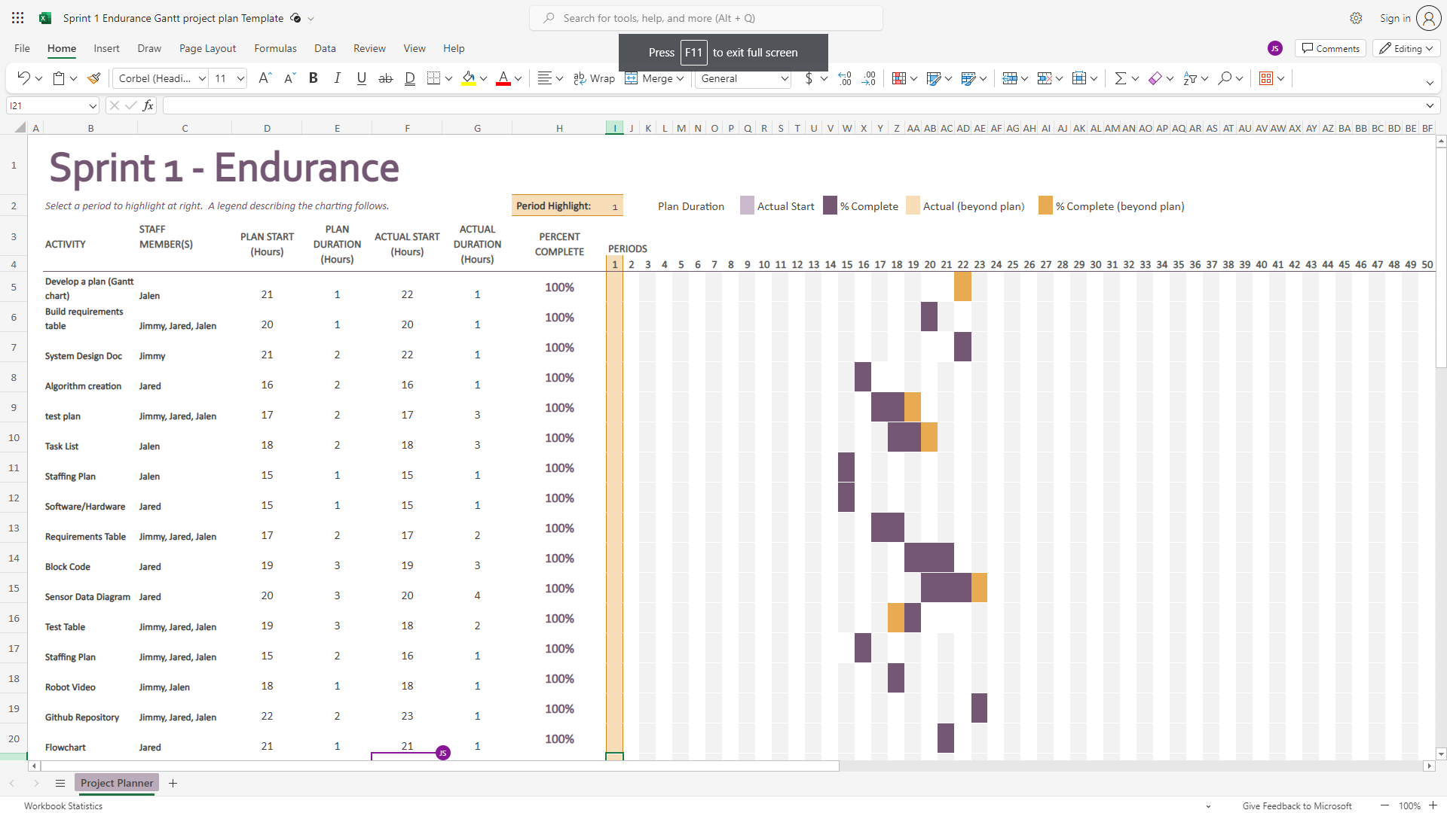

**(Zoom 200% for better visibility)**

## Staffing Plan

| Name | Role | Responsibility | Reports To |
| --- | --- | --- | --- |
| Jalen | Project Manager | * Complete Gantt Chart * Complete Staff Plan * Complete block code and sensory data | Group |
| Jimmy | Repository Host | * Edit and submit system design document * Record robot video(s) | Group |
| Jared | Programmer | * List requirements and complete requirements table * Create algorithm and flowchart | Group |